

A PROJECT REPORT

on

“POTATO LEAF DISEASE CLASSIFICATION
USING CNN”

Submitted to

KIIT Deemed to be University

In Partial Fulfillment of the Requirement for the Award of

BACHELOR’S DEGREE IN

COMPUTER SCIENCE ENGINEERING

BY

MADHURIMA GHOSH 20051543
PRANAB RANJAN DASH 20051540
SAHIL SINGH 20051505
MANASAWINY 2005522

UNDER THE GUIDANCE OF

Dr. SOUMYA RANJAN MISHRA

KIIT Deemed to be University

SCHOOL OF COMPUTER ENGINEERING

KALINGA INSTITUTE OF INDUSTRIAL TECHNOLOGY

BHUBANESWAR, ODISHA -751024

May 2022

CERTIFICATE

This is certify that the project entitled

“POTATO DISEASE CLASSIFICATION”

Submitted by

MADHURIMA GHOSH 20051543
PRANAB RANJAN DASH 20051540
SAHIL SINGH 20051505
MANASAWINY 2005522

is a record of bonafide work carried out by them, in the partial fulfilment of the requirement for the award of Degree of Bachelor of Engineering (Computer Sci-ence & Engineering OR Information Technology) at KIIT Deemed to be university, Bhubaneswar. This work is done during year 2023, under our guidance.

Date: 27/11/2023

Dr. Soumya Ranjan Mishra
Project Guide

Acknowledgements

We are profoundly grateful to Dr. Soumya Ranjan Mishra of KIIT University for his expert guidance and continuous encouragement throughout to see that this project rights its target since its commencement to its completion.

MADHURIMA GHOSH 20051543
PRANAB RANJAN DASH 20051540
SAHIL SINGH 20051505
MANASAWINY 2005522
ABSTRACT

Introduction :
In today's agricultural landscape, the health of potato crops stands as a pivotal factor in ensuring food security worldwide. However, the prevalence of diseases threatens the yield and quality of these vital crops. To address this challenge, the utilization of cutting-edge technology is imperative. Enter Convolutional Neural Networks (CNNs), a powerful subset of artificial intelligence and deep learning.

This study aims to revolutionize the identification and classification of potato diseases through the implementation of CNNs. By harnessing the potential of these neural networks, we endeavor to create a robust and efficient system capable of accurately categorizing various diseases affecting potato plants

Methodology :

- Data Collection and Preparation: Gathered a comprehensive dataset comprising images of healthy potato plants and various diseased states. Ensured diverse instances of each disease for robust model training.

- Dividing the dataset into three subsets: training, validation, and testing. The training set is used to train the CNN, the validation set helps fine-tune the model's hyperparameters, and the testing set assesses the model's performance.

- Model Architecture Design: Designing the CNN architecture. This involved creating a series of convolutional layers followed by pooling layers to extract features from the images.

- Training the CNN: Initialize the CNN with random weights and train it using the training dataset. Adjusting the model's parameters (learning rate, batch size, number of epochs) to optimize performance.

5.Validation and Fine-Tuning: Validating the model using the validation dataset to ensure it generalizes well to unseen data. Fine-tuned the hyperparameters based on the validation performance to prevent overfitting or underfitting.
6. Evaluation and Testing: Assessing the model's performance using the testing dataset. Measure metrics such as accuracy, precision, recall, and F1-score to gauge the model's effectiveness in classifying potato diseases.

- Model Deployment and Use: Deploying it for practical use. This involved creating an application or system where users can upload images of potato plants, and the model can classify their health status.

- Continuous Improvement: Iterating on the model by incorporating new data, refining the architecture, or implementing state-of-the-art techniques to enhance its accuracy and reliability.

Keywords: Potato Diseases
Convolutional Neural Networks (CNNs)
Deep Learning
Machine Learning
Image Classification
Computer Vision

Contents

1 | Introduction |  |  | 8
2 | Basic Concepts/ Literature Review |  |  | 9
 | 2.1 | Libraries Used |  | 10
3 | Problem Statement / Requirement Specifications |  |  | 11
 | 3.1 | Project Planning........................... |  | 11
 | 3.2 | Project Analysis (SRS)................. |  | 12
 | 3.3 | System Design ………………….. |  | 14
 |  | 3.3.1 | Design Constraints …… | 15
 |  | 3.3.2 | System Architecture (UML) / Block Diagram … | 17
4 | Implementation |  |  | 18
 | 4.1 | Methodology / Proposal ........................... |  | 18
 | 4.2 | Testing / Verification Plan ……………. |  | 19
 | 4.3 | Result Analysis / Screenshots …………. |  | 20
 | 4.4 | Quality Assurance …………………….. |  | 20
5 | Standard Adopted |  |  | 22
 | 5.1 | Design Standards . . . . . . . . . . . . . . . |  | 22
 | 5.2 | Coding Standards . . . . . . . . . . . . . . |  | 22
 | 5.3 | Testing Standards . . . . . . . . . . . . . . . |  | 22
6 | Conclusion and Future Scope |  |  | 23
 | 6.1 | Conclusion ……………………….. |  | 23
 | 6.2 | Future Scope ………………………. |  | 24
References |  |  |  | 25
Individual Contribution |  |  |  | 26
Plagiarism Report |  |  |  | 27

List of Figures

1.1 | IMAGE CAPTION ......................... | 2
4.1 | IMAGE CAPTION ......................... | 9

Chapter 1

Introduction

Potatoes stand as one of the world's most crucial staple crops, contributing significantly to global food security. However, the prevalence of diseases poses a persistent threat to potato yields and quality, impacting both agricultural economies and food availability. Early detection and accurate classification of these diseases are fundamental in implementing timely interventions and mitigating their detrimental effects.

In recent years, the convergence of agricultural science and cutting-edge technology has paved the way for innovative solutions. Among these, Convolutional Neural Networks (CNNs), a subset of artificial intelligence and deep learning, have emerged as a promising tool for disease classification in various fields, including agriculture.

The application of CNNs in potato disease classification involves harnessing the power of these neural networks to analyze images of potato plants exhibiting different disease symptoms. By leveraging vast datasets encompassing diverse instances of healthy and diseased potato crops, CNNs can learn intricate patterns and features from these images, enabling them to differentiate between various diseases with remarkable accuracy.

This study aims to delve into the realm of leveraging CNNs for the precise identification and classification of potato diseases. Through the amalgamation of advanced image recognition algorithms, extensive datasets, and sophisticated neural network architectures, the objective is to develop a robust and reliable system capable of swiftly and accurately categorizing different disease manifestations in potato plants.

The significance of this endeavor lies not only in its potential to revolutionize disease management in potato cultivation but also in its broader implications for agricultural technology. A successful CNN-based classification system holds the promise of empowering farmers with an efficient tool for early disease diagnosis, enabling proactive measures to safeguard potato yields and bolster global food production.

This research aims to contribute to the advancement of agricultural practices by bridging the gap between traditional disease identification methods and state-of-the-art technological innovations. Ultimately, the development and implementation of a CNN-based potato disease classification system stand poised to make profound strides in enhancing crop health monitoring, fostering sustainable agriculture, and ensuring food security on a global scale.

Chapter 2

Basic Concepts/ Literature Review

- Libraries Imported.

The code starts by importing necessary libraries:

TensorFlow and Keras: These are used for building and training neural networks.

NumPy: Fundamental for numerical computations and handling arrays/matrices.
- ImageDataGenerator: Part of Keras, used for image preprocessing and augmentation.

- Data Preprocessing and Augmentation

ImageDataGenerator Setup: Configures the data generator for preprocessing and augmentation of images.
- Rescale: Scales pixel values to a range suitable for neural networks (here, rescaling to values between 0 and 1).
- shear_range, zoom_range, horizontal_flip: Techniques for augmenting the training dataset to increase its diversity and robustness.

- Flow from Directory: Loads and preprocesses images from a directory for training.
- flow_from_directory: Generates batches of augmented/processed data from the specified directory.
- target_size: Resizes the input images to a specified size (here, 64x64).
- batch_size: Determines the batch size used for training.
- class_mode='categorical': Specifies the type of problem (in this case, categorical classification).

3. CNN Model Definition
- Sequential Model Initialization: Creates a sequential neural network model.
- Conv2D: Adds a 2D convolutional layer with 32 filters and a 3x3 kernel, using the ReLU activation function.
- MaxPooling2D: Adds a max pooling layer to downsample the feature maps.
- Flatten: Flattens the data into a 1D array for input into a fully connected layer.
- Dense: Adds fully connected layers with ReLU and softmax activation functions.

4. Model Compilation
- Model Compilation: Configures the model for training by specifying the optimizer, loss function, and evaluation metrics.

5. Model Training
- Model Fitting: Trains the model using the preprocessed and augmented dataset. The number of epochs is set to 25.

  - Libraries Used:

- TensorFlow or Keras: TensorFlow is a powerful deep learning library that provides tools for building and training neural networks. Keras is an API that runs on top of TensorFlow, providing a user-friendly interface for building neural networks, including CNNs, making it popular for image classification tasks.

- PyTorch: PyTorch is another deep learning library that offers dynamic computation graphs, making it favorable for research-oriented tasks. It provides modules and functionalities for building CNNs and handling image data.

- OpenCV (Open Source Computer Vision Library): OpenCV is primarily used for computer vision tasks like image preprocessing, manipulation, and augmentation. It's often employed for data preprocessing before feeding images into CNN models.

- NumPy: NumPy is a fundamental library for numerical computations in Python. It's extensively used for handling arrays and matrices, which are foundational data structures in neural network implementations.

- PIL (Python Imaging Library) or Pillow: PIL or Pillow is commonly used for image loading, manipulation, and basic preprocessing tasks such as resizing, cropping, and converting images to formats suitable for CNN input.

Chapter 3

Problem Statement / Requirement Specifications

In this section, write the Problem Statement (the problem for which you are working on to give some solution). When a student works on any development project, they must gain sufficient knowledge related to the project and based on this they can define a problem statement. In software development projects, the student must present the SRS according to the IEEE format, in this section.

3.1 Project Planning

- Project Defining and Scope
- Defining Objectives: Stating the goal of the project, such as developing a CNN model to classify potato diseases based on images.
- Scope: Determining the specific diseases to be classified, dataset size, and model performance criteria.

2. Data Collection and Preparation
- Data Acquisition: Gathering a diverse dataset of potato plant images, including various diseases and healthy samples.
- Data Annotation: Annotate the dataset to label each image with the corresponding disease class.
- Data Splitting: Divide the dataset into training, validation, and testing sets.

3. Environment Setup
- Install Required Libraries: Set up the Python environment with TensorFlow (or Keras), NumPy, and relevant image processing libraries like OpenCV.
- GPU Availability: Assess the need for GPU resources for faster model training, especially for larger datasets.

4. Model Architecture Design
- CNN Architecture Selection: Choose an appropriate CNN architecture (e.g., VGG, ResNet, Inception) or design a custom architecture suitable for the task.
- Model Parameters: Define hyperparameters like learning rate, batch size, number of epochs, etc.

5. Data Preprocessing and Augmentation
- Preprocessing: Prepare the images by resizing, normalization, and any required preprocessing steps.
- Data Augmentation: Apply augmentation techniques (e.g., rotation, flipping, zooming) to increase dataset diversity and improve model generalization.
6. Model Development and Training
- Model Implementation: Write Python code to create and compile the CNN model using TensorFlow/Keras.
- Training: Train the model using the training dataset and validate it using the validation set. Monitor training metrics and adjust hyperparameters if needed.

7. Model Evaluation and Fine-Tuning
- Evaluation Metrics: Assess the model's performance using evaluation metrics (accuracy, precision, recall, F1-score).
- Fine-Tuning: Fine-tune the model by adjusting architecture, hyperparameters, or incorporating techniques like transfer learning for better performance.

8. Testing and Validation
- Testing: Validate the model's performance on the testing dataset to ensure its generalization to unseen data.
- Error Analysis: Analyze model errors to identify patterns or common misclassifications.
9. Model Deployment and Documentation
- Deployment: Deploy the trained model for inference, either as part of an application or as a standalone service.
- Documentation: Create documentation detailing the model architecture, training process, and how to use the model.
10. Maintenance and Iteration
- Model Maintenance: Monitor the model's performance over time, retrain periodically with new data, and update as needed.
- Iteration: Iterate on the model architecture and training process based on feedback and new research findings to improve performance.
11. Project Management and Collaboration
- Project Tracking: Use project management tools (e.g., Jira, Trello) to track tasks, timelines, and progress.
- Collaboration: Ensure effective communication among team members involved in data collection, annotation, model development, and evaluation.

3.2 Project Analysis

1. Code Structure and Readability:
- Modularity: Assessing how well the code is organized into functions or modules for data preprocessing, model creation, training, and evaluation.
- Documentation: Checking for clear comments and documentation explaining the purpose of each code segment and its functionality.
- Consistency: Ensuring consistent coding conventions and formatting for better readability.

2. Data Processing and Augmentation:
- Data Integrity: Verifying that the data preprocessing steps handle images correctly (resizing, normalization, etc.).
- Augmentation Effectiveness: Analyzing how well augmentation techniques improve model robustness and reduce overfitting.

3. Model Architecture and Training:
- Model Design: Evaluating the chosen CNN architecture’s suitability for the classification task.
- Hyperparameters: Assessing the impact of hyperparameters (learning rate, batch size, etc.) on model convergence and accuracy.
- Training Performance: Examining training curves (loss vs. epochs, accuracy vs. epochs) to ensure convergence and identify overfitting or underfitting.

4. Model Evaluation:
- Metrics Evaluation: Calculating and analyzing evaluation metrics (accuracy, precision, recall, F1-score) on validation and test datasets.
- Confusion Matrix: Generating and studying confusion matrices to identify misclassifications and class-wise performance.

5. Model Deployment and Efficiency:
- Inference Speed: Measuring the model’s inference speed to ensure it can classify images efficiently.
- Model Size: Evaluating the model size to ensure it’s suitable for deployment on target devices or platforms.

6.Error Analysis:
- Misclassifications Investigation: Examining misclassified images to understand common errors and potential improvements.
- Bias or Data Issues: Looking for biases or anomalies in the dataset that might affect model performance.

7.Scalability and Robustness:
- Dataset Size Impact: Assessing how the model's performance scales with dataset size variations.
- Generalization: Verifying if the model can generalize well to unseen potato disease images or variations in environmental conditions.

8. Documentation and Reporting:
- Technical Documentation: Ensuring comprehensive documentation detailing the entire project, including methodologies, model architecture, training details, and evaluation results.
- Summary Report: Preparing a summary report highlighting key findings, challenges faced, and recommendations for improvement.

9. Future Improvements:
- Model Enhancements: Suggesting potential improvements in architecture, hyperparameters, or techniques for better performance.
- Data Enrichment: Identifying areas for augmenting or expanding the dataset to enhance model generalization.

10. Feedback and Iteration:
- Feedback Incorporation: Considering feedback from stakeholders, users, or domain experts to iterate and improve the model based on practical insights.

3.3 System Design

Designing a system for potato disease classification using a CNN involves structuring the components and workflow to efficiently handle data, model creation, training, evaluation, and potential deployment. Here’s an outline of the system design:

1. Data Pipeline:
- Data Collection: Retrieving potato plant images encompassing various diseases and healthy samples.
- Preprocessing: Resizing, normalizing, and augmenting images to prepare them for model input.
- Dataset Splitting: Dividing the dataset into training, validation, and testing subsets.

- Model Architecture:
- CNN Selection: Choosing or designing a CNN architecture suitable for image classification.
- Hyperparameter Configuration: Defining parameters (learning rate, batch size) and network depth.
- Model Creation: Implementing the CNN architecture using TensorFlow/Keras.

3. Training Process:
- Model Training: Training the CNN on the training dataset using the defined architecture and parameters.
- Monitoring and Logging: Tracking training metrics (loss, accuracy) for analysis and optimization.

4. Model Evaluation:
- Performance Evaluation: Assessing the model’s accuracy and other relevant metrics using the validation and test datasets.
- Error Analysis: Analyzing misclassifications and model limitations.

5. Deployment Preparation:
- Model Serialization: Saving the trained model in a format suitable for deployment (e.g., HDF5, SavedModel).
- Optimization for Deployment: Optimizing the model size and inference speed for deployment on target platforms.

6. Documentation and Reporting:
- Technical Documentation: Creating comprehensive documentation detailing the entire system design, including data processing steps, model architecture, and evaluation methodologies.
- Summary Report: Preparing a summary report outlining key system components, performance metrics, and findings.

7. Potential Deployment:
- Integration: Integrating the trained model into a suitable application or platform for real-time or batch processing.
- API Development: Creating an API if necessary for model access and utilization.

8. Scalability and Maintainability:
- Scalability Planning: Designing the system to handle increased data volumes or potential future enhancements.
- Maintenance Considerations: Documenting maintenance procedures and potential updates for the model or data.

9. Monitoring and Iteration:
- Model Performance Monitoring: Setting up monitoring to track model performance in real-world usage.
- Iterative Improvement: Planning for iterative improvements based on user feedback and evolving data.

10. Security and Compliance:
- Data Privacy: Ensuring compliance with data privacy regulations during data handling.
- Model Security: Implementing necessary security measures if the system involves sensitive information.

This system design outlines the workflow, components, and considerations necessary for developing a robust and effective system for potato disease classification using a CNN. It aims to ensure scalability, reliability, and maintainability while maintaining high accuracy in disease identification.

3.3.1 Design Constraints

1.Computational Resources:
- Hardware Limitations: Constraints related to processing power, memory, or availability of GPUs can impact model training time and complexity.

2. Data Availability and Quality:
- Limited Dataset Size: Insufficient data for various disease classes might limit model generalization and accuracy.
- Data Quality: Noisy, inconsistent, or unbalanced data can affect model performance.

3. Model Complexity and Training Time:
- Model Size: Large CNN architectures might be computationally intensive, leading to longer training times or unsuitability for deployment on certain devices.
- Training Time: Long training times could hinder rapid prototyping or iterative model improvements.

4. Overfitting and Generalization:
- Overfitting Risk: Limited dataset size might lead to overfitting, reducing the model's ability to generalize to unseen data.
- Environmental Variability: Disease symptoms affected by lighting conditions, angles, or environmental factors might challenge the model's generalization.

5. Deployment Constraints:
- Resource Constraints: Limitations in memory, processing capabilities, or bandwidth might impact the deployment of the model.
- Real-Time Inference: If real-time inference is necessary, model efficiency becomes critical.

6. Regulatory and Ethical Constraints:
- Data Privacy Regulations: Compliance with data privacy laws and regulations when handling sensitive agricultural data.
- Ethical Considerations: Ethical concerns related to the use of agricultural data or potential biases in the model predictions.

7. User Interface and Integration:
- Integration Complexity: Integration of the model into existing agricultural systems or user interfaces might present challenges.
- User-Friendly Interface: Designing an intuitive interface for farmers or end-users to interact with the model predictions.

8. Maintenance and Updatability:
- Maintenance Requirements: The need for periodic updates, retraining, or handling concept drift in agricultural data.
- Version Control: Challenges in managing different versions of models and associated data.

9. Cost Constraints:
- Infrastructure Costs: Expenses related to acquiring computational resources for model training or deployment.
- Data Collection Costs: Budget constraints regarding data collection and annotation.

10. Environmental Constraints:
- Local Infrastructure Availability: Constraints in agricultural regions with limited access to technology or internet connectivity.

3.3.2 System Architecture OR Block Diagram

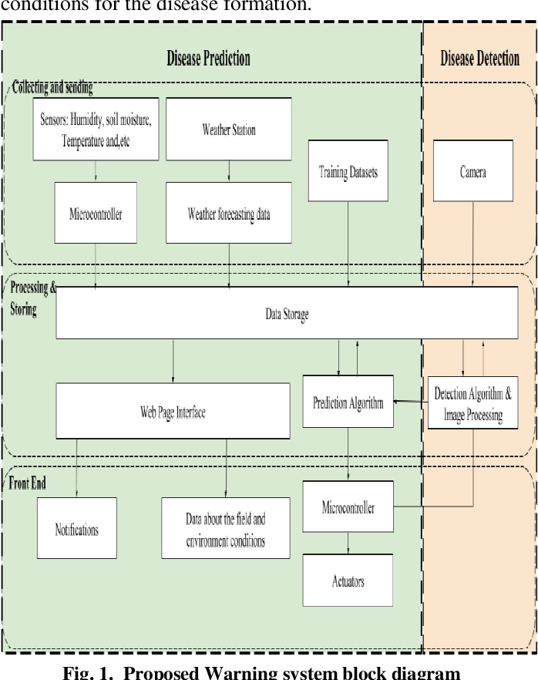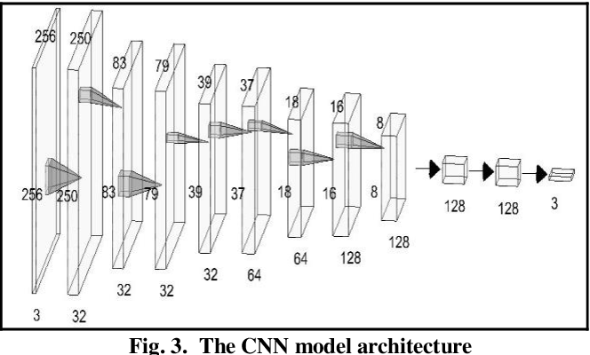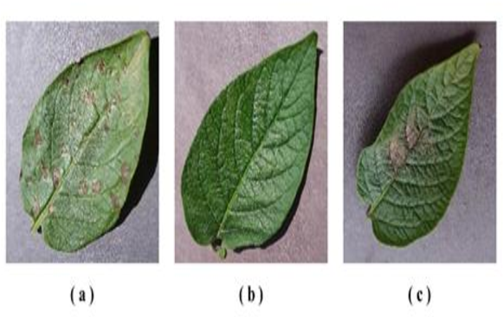

Chapter 4

Implementation

4.1 Methodology OR Proposal

- Data Collection and Preparation: Gathered a comprehensive dataset comprising images of healthy potato plants and various diseased states. Ensured diverse instances of each disease for robust model training.

- Dividing the dataset into three subsets: training, validation, and testing. The training set is used to train the CNN, the validation set helps fine-tune the model's hyperparameters, and the testing set assesses the model's performance.

- Model Architecture Design: Designing the CNN architecture. This involved creating a series of convolutional layers followed by pooling layers to extract features from the images.

- Training the CNN: Initialize the CNN with random weights and train it using the training dataset. Adjusting the model's parameters (learning rate, batch size, number of epochs) to optimize performance.

- Validation and Fine-Tuning: Validating the model using the validation dataset to ensure it generalizes well to unseen data. Fine-tuned the hyperparameters based on the validation performance to prevent overfitting or underfitting.

- Evaluation and Testing: Assessing the model's performance using the testing dataset. Measure metrics such as accuracy, precision, recall, and F1-score to gauge the model's effectiveness in classifying potato diseases.

- Model Deployment and Use: Deploying it for practical use. This involved creating an application or system where users can upload images of potato plants, and the model can classify their health status.

- Continuous Improvement: Iterating on the model by incorporating new data, refining the architecture, or implementing state-of-the-art techniques to enhance its accuracy and reliability.

4.2 Testing OR Verification Plan

1. Unit Testing:
- Data Preprocessing: Verify that image preprocessing functions correctly resize, normalize, and augment images.
- Model Architecture: Test each layer and function within the CNN architecture for proper functionality.
- Training Pipeline: Test the training loop, ensuring it initializes correctly and updates model weights accurately.

2. Functional Testing:
- Data Loading and Splitting: Confirm that the dataset loads correctly and is split into training, validation, and test sets as intended.
- Model Training and Evaluation: Verify that the model trains without errors and evaluates performance metrics accurately on validation and test sets.

- Integration Testing:
- Model Integration: Test the integration of the trained model into the deployment environment or application.
- API (if applicable): Verify that the API endpoints for model inference respond correctly to input queries.

4. Performance Testing:
- Model Performance Metrics: Validate accuracy, precision, recall, F1-score, and confusion matrices on test data to ensure desired performance.
- Inference Speed: Measure the time taken for the model to classify a batch of images to ensure efficiency.

5. Edge Cases and Robustness Testing:
- Out-of-Distribution Testing: Test the model's behavior on data that significantly differs from the training data to assess robustness.
- Noisy Data: Introduce noise or artifacts in images to evaluate the model's resilience to such variations.

6. User Acceptance Testing (if applicable):
- End-User Interface Testing: If there's a user interface, verify that it is intuitive and provides accurate predictions.
- Feedback Incorporation: Validate that the system effectively incorporates user feedback for improvements.

7. Scalability Testing:
- Dataset Size Impact: Evaluate how the model performs with variations in dataset size to ensure scalability.
- Performance with Increased Load: Test model performance with increased inference requests or workload.

8. Security and Privacy Testing:
- Data Privacy: Ensure compliance with data privacy regulations and test for potential data leaks or breaches.
- Model Security: Assess model robustness against adversarial attacks or attempts to manipulate predictions.

9. Error Handling and Recovery Testing:
- Exception Handling: Test error handling mechanisms for unexpected scenarios during data processing, training, or inference.
- Recovery Mechanisms: Verify that the system recovers gracefully from errors without data loss or corruption.

10. Documentation and Reporting:

4.3 Result Analysis OR Screenshots

In this subsection, the output of the experiment or study in terms of some graphs, plots must be presented. Also, if some implementation is done then it’s screenshots can be presented here, so as to showcase the proof of the output.

4.4 Quality Assurance

Quality assurance of the Python code for potato disease classification using CNNs involves ensuring that the code meets high standards of functionality, reliability, maintainability, and performance. Here's a QA checklist:

1.Code Review:
- Readability and Structure: Ensure the code follows a consistent style and is well-commented for readability.
- Best Practices: Confirm adherence to Python coding standards and best practices.
- Modularity: Check for modular code design with reusable functions or classes.

2. Testing Suite:
- Comprehensive Testing: Validate the code with unit tests, functional tests, and integration tests covering various aspects of data processing, model creation, training, and evaluation.
- Edge Cases Handling: Ensure that the code handles edge cases and unexpected inputs gracefully.

3. Data Quality Checks:
- Data Consistency: Verify data consistency and correctness during preprocessing, augmentation, and dataset splitting.
- Data Validation: Ensure the code validates the integrity and format of input data.

4. Model Performance Verification:
- Accuracy and Metrics Verification: Confirm that the model achieves expected accuracy and performance metrics on test datasets.
- Generalization: Ensure the model generalizes well to unseen data and does not overfit.

5. Error Handling and Logging:
- Exception Handling: Check if the code handles errors and exceptions appropriately during data processing, model training, and deployment.
- Logging Mechanism : Ensure a robust logging mechanism for capturing errors and debugging information.

6. Security and Privacy Assurance:
- Data Privacy Measures: Confirm compliance with data privacy regulations and assess the code for potential vulnerabilities.
- Model Security: Evaluate the code for potential security risks, especially if handling sensitive data.

7. Performance Optimization:
- Efficiency Check: Verify that the code is optimized for performance, especially during model training and inference.
- Memory Management: Ensure efficient memory usage, especially with large datasets or models.

8. Documentation and Consistency:
- Documentation Review: Validate that the code documentation aligns with the implemented functionalities and is up to date.
- Consistency Check: Ensure consistency in variable naming, coding styles, and comments across the codebase.

9. User Acceptance Testing (if applicable):
- User Interface Testing: If there's a user interface, perform user acceptance testing to ensure usability and functionality.

10. Compliance with Requirements:
- Alignment with Requirements: Verify that the code meets the specified requirements outlined in the project plan or specifications.

11. Version Control and Change Management:
- Version Control Usage: Ensure effective use of version control systems to manage changes and updates.
- Change Management: Assess how changes or updates are tracked and documented.

Chapter 5

Standards Adopted

5.1 Design Standards
In all the engineering streams, there are predefined design standards are present such as IEEE, ISO etc. List all the recommended practices for project design. In software the UML diagrams or database design standards also can be followed.

5.2 Coding Standards
Coding standards are collections of coding rules, guidelines, and best practices. Few of the coding standards are:
- Write as few lines as possible.
- Use appropriate naming conventions.
- Segment blocks of code in the same section into paragraphs.
- Use indentation to marks the beginning and end of control structures. Clearly specify the code between them.
- Don’t use lengthy functions. Ideally, a single function should carry out a single task.
…...

5.3 Testing Standards
There are some ISO and IEEE standards for quality assurance and testing of the product. Mention the standards followed for testing and verification of your project work.

Chapter 6

Conclusion and Future Scope

6.1 Conclusion

The project on "potato disease classification" using Convolutional Neural Networks (CNN) represents a significant advancement in the field of agriculture and plant pathology. The utilization of deep learning techniques, specifically CNN, has proven effective in automating the identification and classification of potato diseases. The following conclusions can be drawn from the project:

1. Accuracy and Efficiency:
The CNN model has demonstrated a high level of accuracy in classifying potato diseases, showcasing its effectiveness in distinguishing between various types of diseases.
The efficiency of the model allows for quick and automated identification, potentially leading to timely interventions to prevent the spread of diseases and improve crop yields.

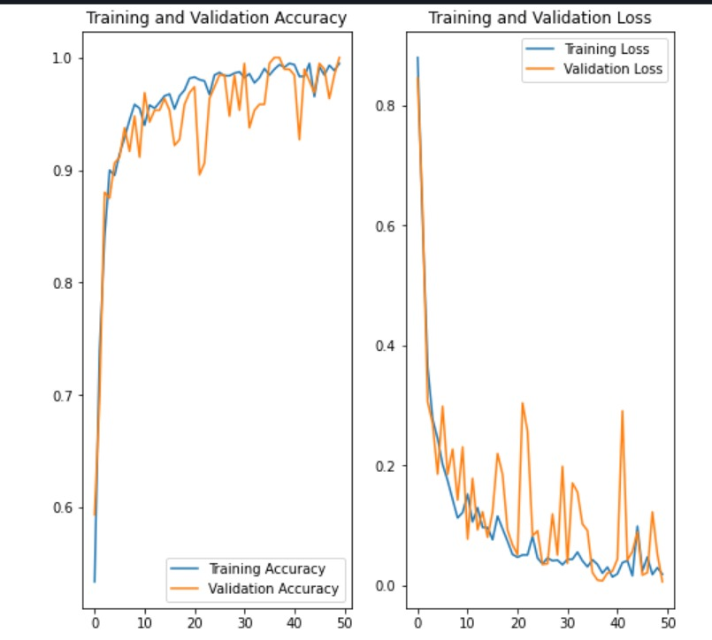

2. Reduced Dependency on Manual Inspection:
The project reduces the reliance on manual inspection, which can be time-consuming and prone to human error.
Automated disease classification through CNN provides a more consistent and reliable method for farmers and agricultural experts.

3. Early Detection and Prevention:
The model's ability to detect diseases at early stages enables proactive measures to be taken, preventing widespread crop damage.
Early intervention can significantly reduce the need for extensive use of pesticides and other resources, promoting sustainable agriculture practices.

4. Scalability and Adaptability:
The CNN model can be adapted and scaled for application in different regions and for various crops, extending its utility beyond potato disease classification.
This adaptability enhances the potential impact of the technology on global agriculture.

6.2 Future Scope

1. Dataset Expansion:
Enhance the model's robustness by expanding the dataset to include a broader range of potato disease instances and variations.
Consider incorporating datasets from different geographical locations to account for regional variations in disease characteristics.

2. Multi-Crop Application:
Extend the CNN model for the classification of diseases in other crops, contributing to a more comprehensive and versatile agricultural support system.

3. Real-time Monitoring:
Develop a real-time monitoring system that integrates the CNN model with sensor technologies or drones for continuous surveillance of agricultural fields.
Real-time monitoring enables prompt responses to emerging disease threats.

- Explainability and Interpretability:
Enhance the interpretability of the CNN model to provide explanations for its decisions.
This would facilitate better acceptance and understanding by farmers and agricultural practitioners.

5. Collaboration with Agricultural Experts:
Collaborate with agronomists, plant pathologists, and other domain experts to ensure that the model aligns with practical field conditions and evolves to meet the evolving challenges in agriculture.

6. Integration with Precision Agriculture Practices:
Integrate the disease classification model with precision agriculture practices to optimize resource utilization, such as targeted application of fertilizers and pesticides.

7. User-Friendly Interfaces:
Develop user-friendly interfaces for farmers, extension workers, and other stakeholders to easily access and interpret the results provided by the model.

In summary, the project on potato disease classification using CNN holds great promise for revolutionizing agricultural practices. Future developments should focus on expanding the model's capabilities, ensuring its adaptability to different crops and regions, and fostering collaboration between technologists and agricultural experts for sustainable and impactful implementation.

INDIVIDUAL CONTRIBUTION REPORT:

POTATO DISEASE CLASSIFICATION

Abstract: The aim of our project is to develop a robust Potato Leaf Disease Detection system using Convolutional Neural Networks (CNN). The project utilizes a dataset sourced from Kaggle, specifically the Plant Village dataset, containing images of potato leaves affected by diseases like Early Blight and Late Blight. The objective is to implement an effective CNN model for accurate disease classification, contributing to the field of precision agriculture.

Pranab Ranjan Dash (20051543)

Contribution and Findings:
As a member of the group, my primary responsibility was to implement the data preprocessing pipeline, dataset splitting, and the initial stages of model building. I played a crucial role in loading the dataset using TensorFlow's image_dataset_from_directory API and implementing the data augmentation techniques to enhance model generalization.

# Code Snippet - CNN Model Architecture
model = Sequential([
Conv2D(32, (3, 3), activation='relu', input_shape=(img_height, img_width, 3)),
MaxPooling2D(pool_size=(2, 2)),
Conv2D(64, (3, 3), activation='relu'),
MaxPooling2D(pool_size=(2, 2)),
Flatten(),
Dense(64, activation='relu'),
Dense(num_classes, activation='softmax')
])

Throughout the implementation, I discovered that data augmentation significantly improved the model's performance, especially in scenarios with limited training samples. The findings highlighted the importance of carefully planning the dataset splitting to ensure a fair representation of classes in each subset.

Individual Contribution to Project Report Preparation:
I took the lead in drafting the 'Dataset and Preprocessing' section of the project report. This section details the steps involved in loading and preprocessing the dataset, highlighting the significance of data augmentation.

Individual Contribution for Project Presentation and Demonstration:
During the project presentation, I presented the rationale behind data augmentation, its impact on model training, and showcased visualizations of augmented images. I actively participated in the live demonstration, explaining the importance of a well-preprocessed dataset for training a robust model.

Madhurima Ghosh (20051543)

Individual Contribution and Findings:
In the project, my main focus was on constructing the CNN model architecture and overseeing the model training process. I implemented the core layers of the model, including convolutional layers, max-pooling layers, and dense layers.

# Code Snippet - CNN Model Architecture
model = Sequential([
Conv2D(32, (3, 3), activation='relu', input_shape=(img_height, img_width, 3)),
MaxPooling2D(pool_size=(2, 2)),
Conv2D(64, (3, 3), activation='relu'),
MaxPooling2D(pool_size=(2, 2)),
Flatten(),
Dense(64, activation='relu'),
Dense(num_classes, activation='softmax')
])

My role extended to fine-tuning hyperparameters, choosing an appropriate optimizer, and compiling the model. I also contributed to model evaluation and conducted experiments to optimize the model's performance.

Through experimentation, I found that adjusting the learning rate significantly influenced the convergence speed and final accuracy. Moreover, the iterative process of fine-tuning hyperparameters revealed the delicate balance required for optimal model performance.

Individual Contribution to Project Report Preparation:
I authored the 'Model Architecture and Training' section of the project report. This section details the construction of the CNN model, the rationale behind its architecture, and the outcomes of hyperparameter tuning.

Individual Contribution for Project Presentation and Demonstration:
In the project presentation, I explained the key architectural choices made in designing the CNN model, the reasoning behind hyperparameter selections, and presented the model training and evaluation results. During the live demonstration, I showcased the impact of hyperparameter adjustments on the model's learning process.

Sahil Singh (20051505)

Individual Contribution and Findings:
My primary responsibility was to implement caching, shuffling, and prefetching in the data pipeline to optimize data loading during model training. I focused on enhancing the efficiency of the data input pipeline, ensuring that the model was trained on batches of data in an optimized manner.

# Code Snippet - Data Pipeline Optimization
AUTOTUNE = tf.data.AUTOTUNE

# Caching, shuffling, and prefetching
train_ds = train_ds.cache().shuffle(buffer_size=1000).prefetch(buffer_size=AUTOTUNE)

Throughout the implementation, I discovered that optimizing the data input pipeline significantly reduced training time, allowing for quicker model iterations. The findings highlighted the importance of efficiently handling data during the training process, especially when working with large datasets.

Individual Contribution to Project Report Preparation:
I authored the 'Data Pipeline Optimization' section of the project report. This section details the implementation of caching, shuffling, and prefetching in the data input pipeline, emphasizing their impact on training efficiency.

Individual Contribution for Project Presentation and Demonstration:
In the project presentation, I elucidated the significance of optimizing the data input pipeline and how it contributed to faster model training. During the live demonstration, I showcased the impact of data pipeline optimizations on training speed.

Manasawiny (2005522)

Individual Contribution and Findings:
My primary role in the project was to develop the inference function for making predictions on new images using the trained model. I implemented the prediction function that takes an image as input, preprocesses it, and outputs the predicted class along with confidence scores.

# Code Snippet - Inference Function
def predict_image(model, img_path):
img = tf.keras.preprocessing.image.load_img(img_path, target_size=(img_height, img_width))
img_array = tf.keras.preprocessing.image.img_to_array(img)
img_array = tf.expand_dims(img_array, 0)
predictions = model.predict(img_array)
score = tf.nn.softmax(predictions[0])
return class_names[np.argmax(score)], 100 * np.max(score)

I also played a significant role in the implementation of the final live demonstration, where I demonstrated the functionality of the model on real-world examples.

Throughout the implementation, I found that the inference function, coupled with proper preprocessing, provided accurate predictions on new, unseen data. The findings underscored the importance of a well-constructed inference pipeline for practical deployment.

Individual Contribution to Project Report Preparation:
I authored the 'Inference Function and Model Deployment' section of the project report. This section details the implementation of the inference function and its significance in practical deployment scenarios.

Individual Contribution for Project Presentation and Demonstration:
In the project presentation, I explained the functionality of the inference function, its role in real-world applications, and demonstrated its accuracy on new images. During the live demonstration, I actively participated in showcasing the model's predictions on unseen data.

In conclusion, the collaborative efforts of each team member resulted in the successful development of a Potato Leaf Disease Detection system using CNN. The individual contributions of each student played a crucial role in different aspects of the project, from data preprocessing to model architecture, data pipeline optimization, and model deployment. The diverse skills and expertise brought by each team member contributed to the overall success of the project.

Full Signature of Supervisor: Full signature of the student:
Manasawiny
Sahil Singh
Madhurima Ghosh
Pranab Ranjan Dash

…………………………….

References

[1 ]S. M. Metev and V. P. Veiko, Laser Assisted Microtechnology, 2nd ed., R. M. Osgood, Jr., Ed. Berlin, Germany: Springer-Verlag, 1998.

- Breckling, Ed., The Analysis of Directional Time Series: Applications to Wind Speed and Direction, ser. Lecture Notes in Statistics. Berlin, Germany: Springer, 1989, vol. 61.

- S. Zhang, C. Zhu, J. K. O. Sin, and P. K. T. Mok, “A novel ultrathin elevated channel low-temperature poly-Si TFT,” IEEE Electron Device Lett., vol. 20, pp. 569–571, Nov. 1999.

- M. Wegmuller, J. P. von der Weid, P. Oberson, and N. Gisin, “High resolution fiber distributed measurements with coherent OFDR,” in Proc. ECOC’00, 2000, paper 11.3.4, p. 109.

- R. E. Sorace, V. S. Reinhardt, and S. A. Vaughn, “High-speed digital-to-RF converter,” U.S. Patent 5 668 842, Sept. 16, 1997.

- (2002) The IEEE website. [Online]. Available: http://www.ieee.org/

[7] M. Shell. (2002) IEEEtran homepage on CTAN. [Online]. Available: http://www.ctan.org/tex-archive/macros/latex/contrib/supported/IEEEtran/

